<https://www.youtube.com/watch?v=j5P9FHiBVNo>

ReactJS Tutorial - 20 - Styling and CSS Basics

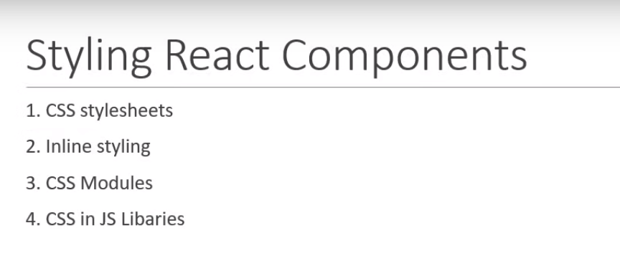

Only first 3 approaches and 4- its will in future.

Create the **component**

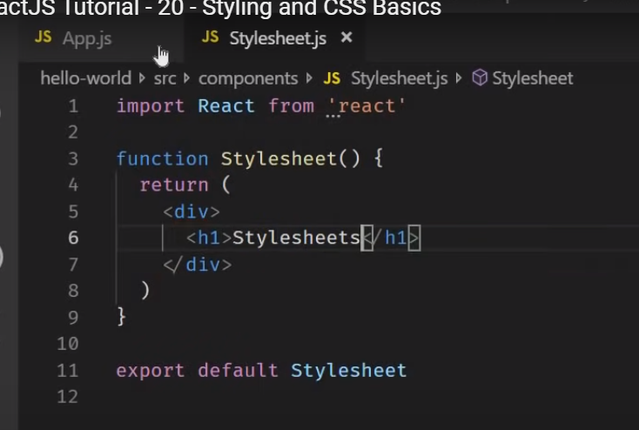

Add in the app.component

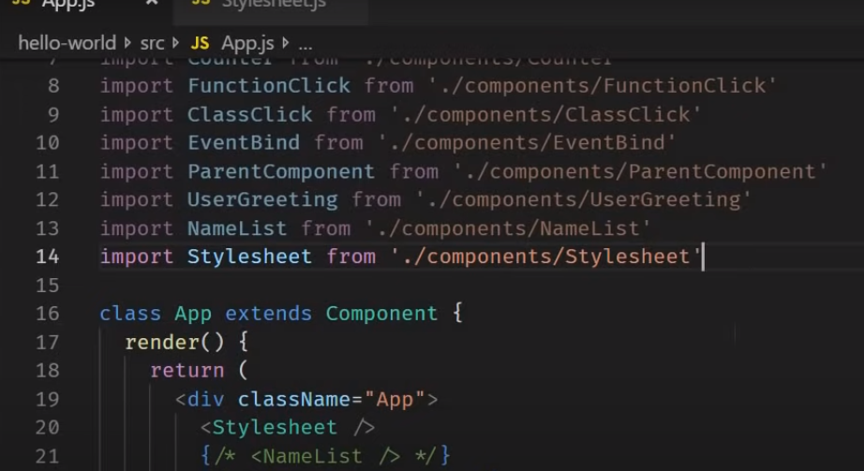

myStyle.css

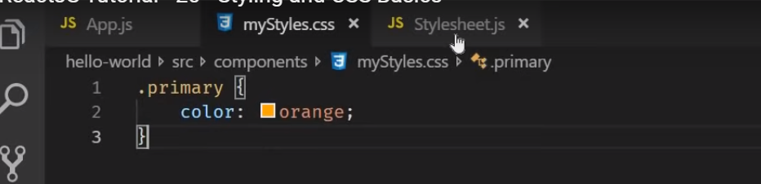

In the component

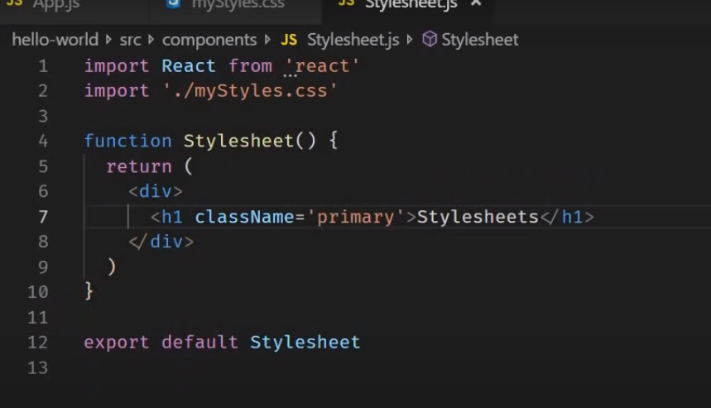

We can also apply conditional class based on props and state of components

Conditional css based on the props: -

Case 1

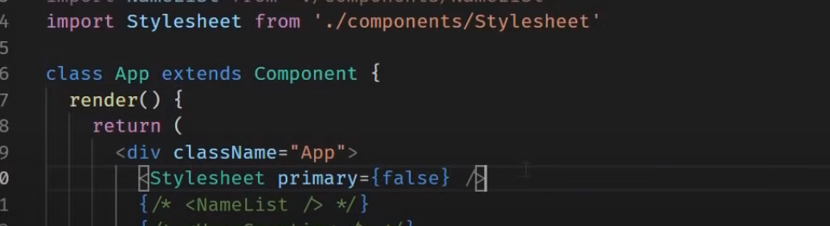

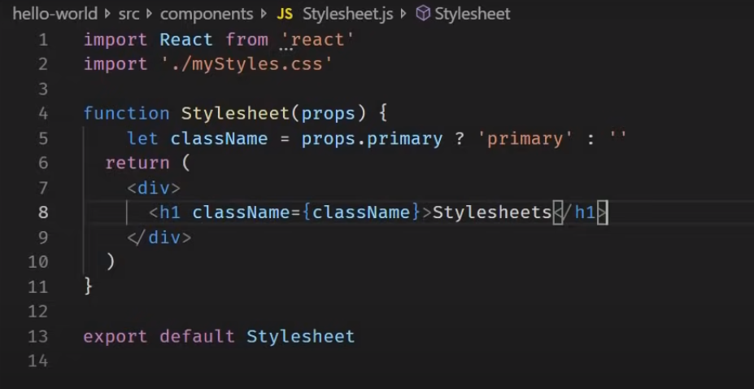

Output : black

Case 2

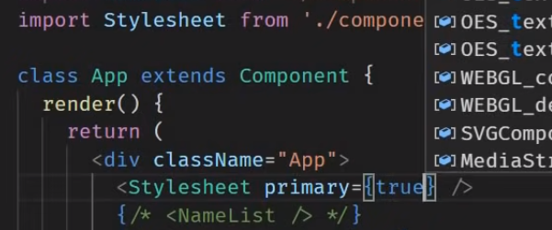

Output colored



Lest make change the code

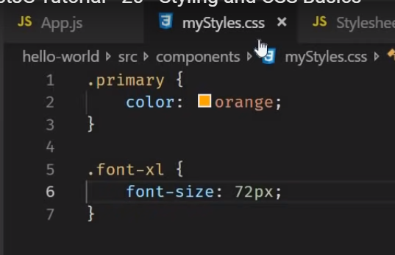

Now lets change the code backlets.

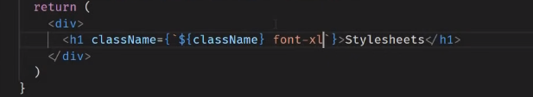

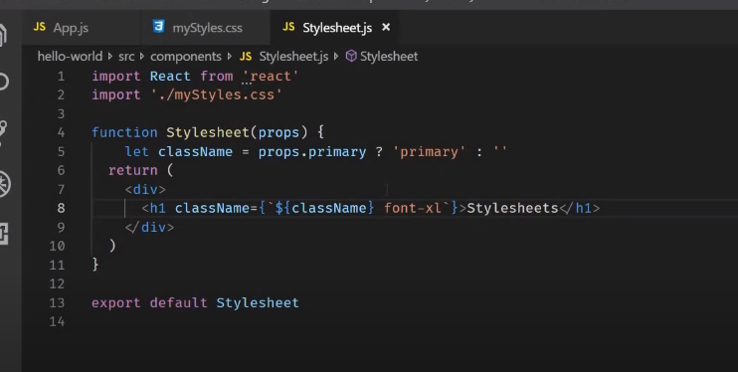

Both classes are applied



Inline Text

How inline text in the react application :-

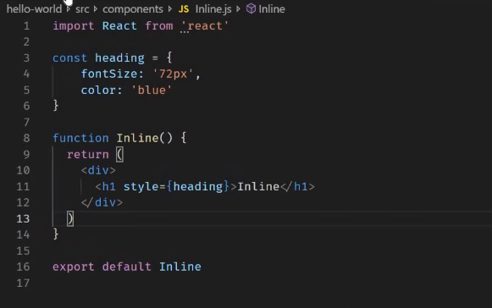

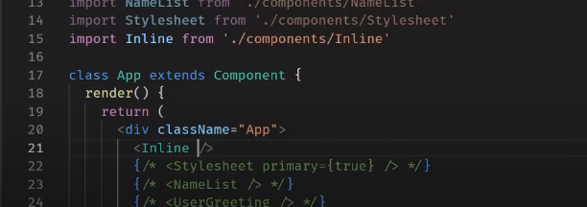



3- **Css modules are available in the react –scripts from react 2 and higher**

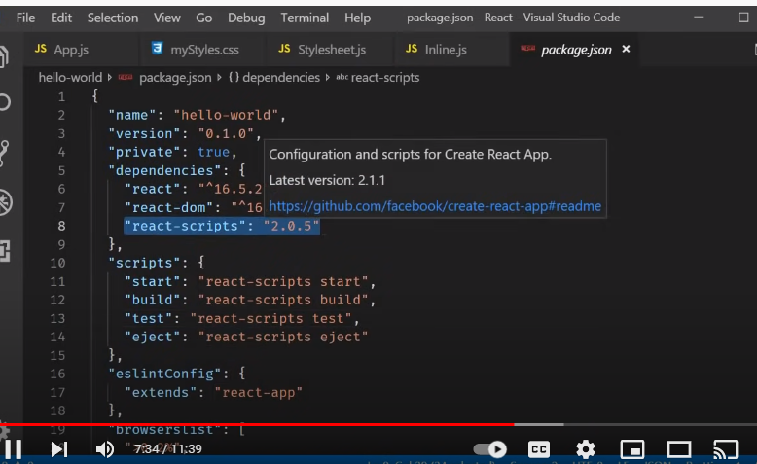

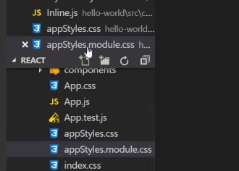

Style :-

**appStyle.css**

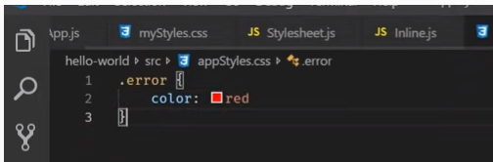

**appStyles.module.css**

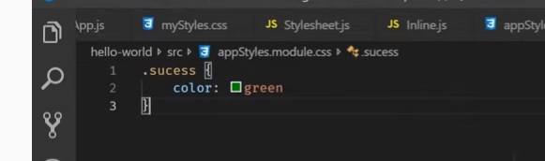

Import in the Appcomonent.

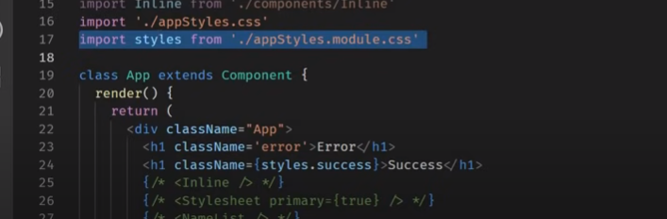

Inline component - lets comment - inline component

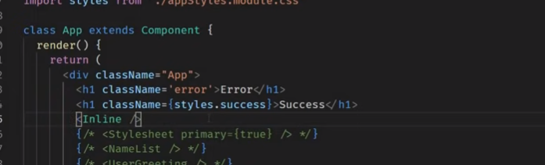

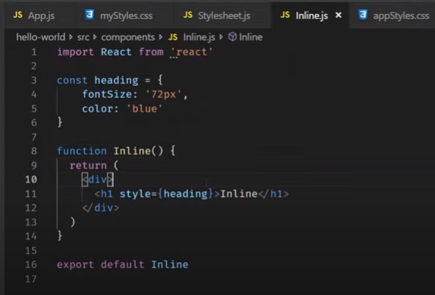

Still works you can view in the every child component – App –parent and inline –child component



If you past the code in chile component - which already defined in the parent one.

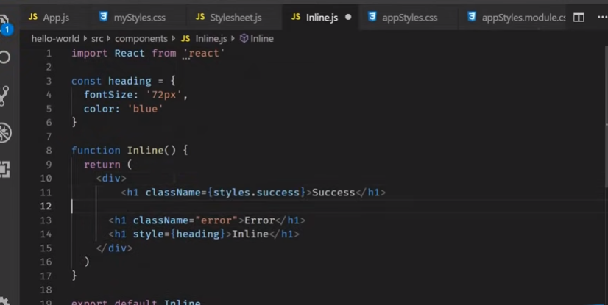

Application does not compile

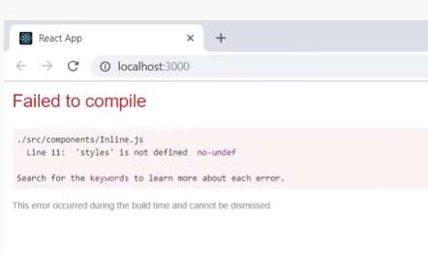

Jsx :-

<https://www.youtube.com/watch?v=7fPXI_MnBOY>

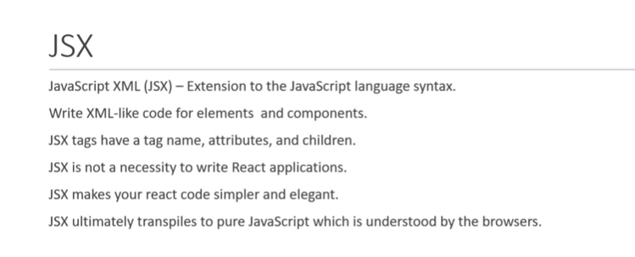

React Application:-

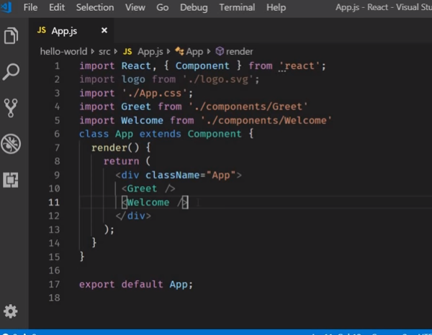

Hello.js –with jsx

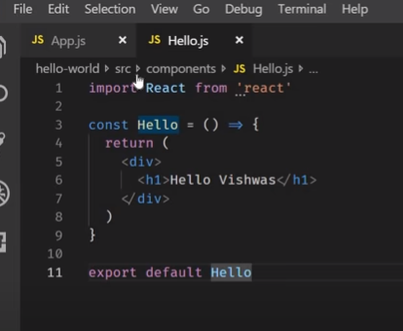

Import in the App.js

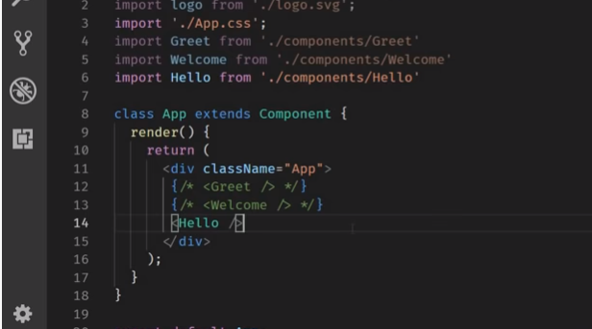

Output:- with out using the jsx

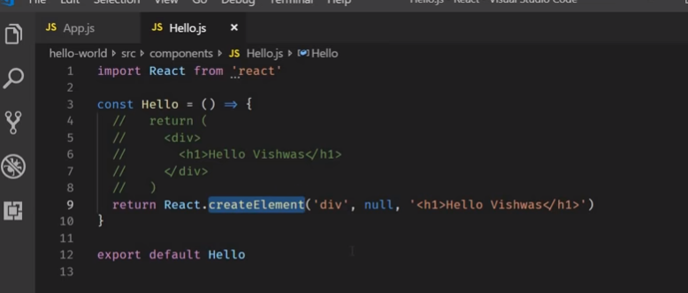

Just text in the .. 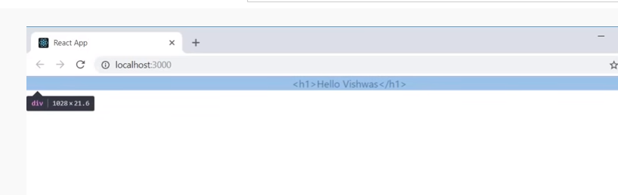

Lets fix this .

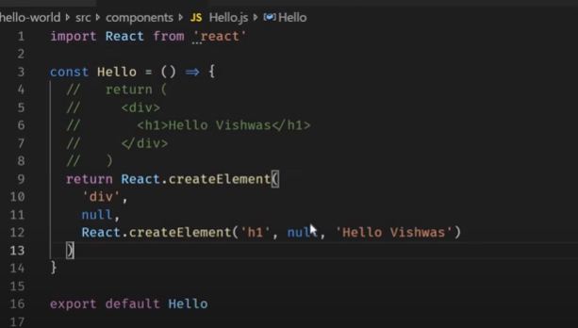

null is the object .. 2nd parameter

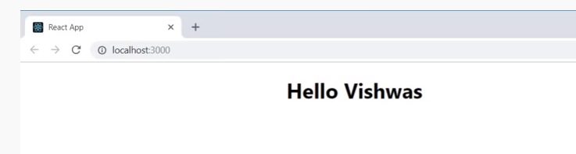

Lets add the second parameter

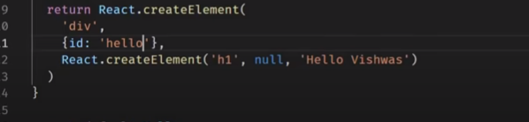

Id : hello and className.. in react application..

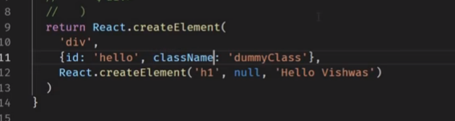

Output

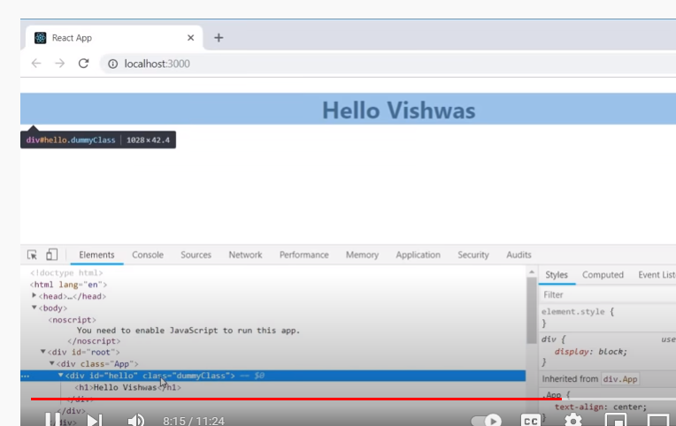

With and with out jsx

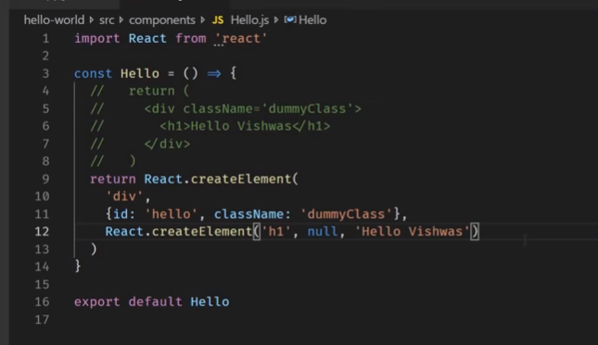

Why react is import in the below code- to broiler code

